**How to start using “R” Scripts inside Tableau : Step by Step**

**1.Tableau with R**

* This blog is intended to show how to leverage R to extend Tableau capabilities and visualize outputs from R.
* This is not a Tutorial on R.

**2.What is R**

* R is an open source programming language and software environment for statistical computing and graphics
* The R language is widely used among statisticians and data miners for developing statistical software and data analysis.

**3.What is R Studio**

* RStudio is a free and open-source Integrated Development Environment (IDE) for R.
* RStudio is available in two editions: RStudio Desktop, where the program is run locally as a regular desktop application; and RStudio Server, which allows accessing RStudio using a web browser while it is running on a remote Linux

**4.Installing R & R Studio**

* Download R from the Link:

[http://cran.us.r-project.org/](https://community.tableau.com/external-link.jspa?url=http%3A%2F%2Fcran.us.r-project.org%2F)

* Download R Studio from the Link:

[https://www.rstudio.com/products/rstudio/download/](https://community.tableau.com/external-link.jspa?url=https%3A%2F%2Fwww.rstudio.com%2Fproducts%2Frstudio%2Fdownload%2F)  
**5.Setting Up Tableau Desktop with R**Tableau communicates with R using a package called Rserve.  
You can install and initiate Rserve from R command line by entering:   
install.packages("Rserve");   
library(Rserve);  
Rserve()[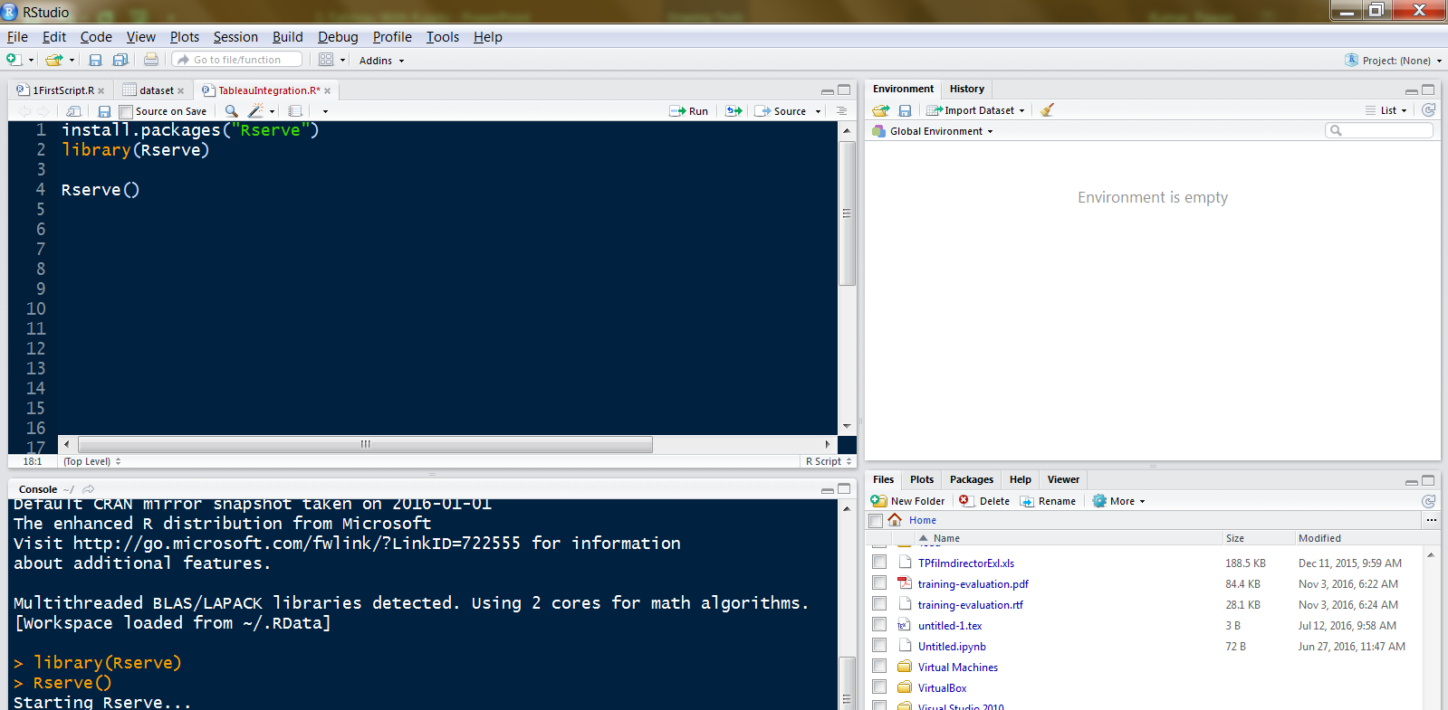](https://lh6.googleusercontent.com/cT-3TRKJGFTl42yB80e3k8tAAEVfW9gpZUl6z6oxDuBPzW1nKqVTayA2lEhlPenEP9iAUGvNXo3JjUtA5qFQSaNLd3HuCRNdEeLQE-u3b7PJkTupksfidNot7E7TZEZ83GBs9I_62mtliMO3VA)  
**6.Configure an Rserve Connection on Tableau**On the Help menu in Tableau Desktop choose Settings and Performance > Manage R Connection to open the Rserve connection dialog box.[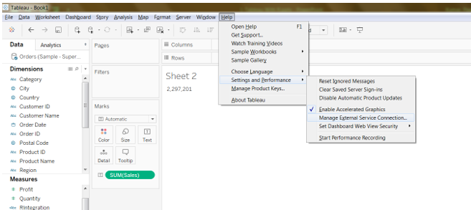](https://lh6.googleusercontent.com/ZkI387UYSdUQ3jLGnIj52Ev_NxqBCuuwKO_X8zbRI4NgPu_FvC3PPOQMDE76CQ2uMxHdTX7GREpUDZen92eQXU1gxegOHP2ckDyO7xG1iMSxM9bq-2j0GFVvXylsHs3vOXkHMXG2HXI1AXNxDw)  
[https://docs.google.com/drawings/d/sBzkE71ihU-gy5wK-JehGyQ/image?w=251&h=43&rev=1&ac=1](https://docs.google.com/drawings/d/sBzkE71ihU-gy5wK-JehGyQ/image?w=251&h=43&rev=1&ac=1)  
  
  
  
  
  
The below screen opens up: [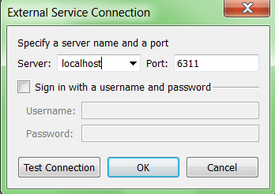](https://lh5.googleusercontent.com/LqgKnNdSe0le8yG9LvWbP0kNAwBelXk5RJDW7uZU0f_eJx6rqKvmubKdvSXN8Yt93XLvsl1Vgw9g83dY9l0aywMn408WkTTMC6DC4mzXaDVTQLWVRMpvuBHJLAh0jcs4FJBF2_fk-u3JufFc2A)  
Enter or select a server name using a domain or an IP address. The drop-down list includes localhost and the server you most recently connected to.   
Specify a port. Port 6311 is the default port for Rserve servers. If the server requires credentials, specify a Username and Password.   
Click Test Connection. Click OK.  
**7. Pass Expressions to R**

* In order to let tableau know that the calculations need to go to R, it must be passed through one of the 4 functions.
* These 4 functions are : SCRIPT_BOOL , SCRIPT_INT , SCRIPT_REAL , SCRIPT_STR
* R Functions are computed as Table calculations in Tableau.
* Since these are table calculations, all the Fields being passed to R must be aggregated like Sum(PROFIT), MIN(Profit), Max (Profit), ATTR( Category) etc.

**8. R Functions in Tableau**[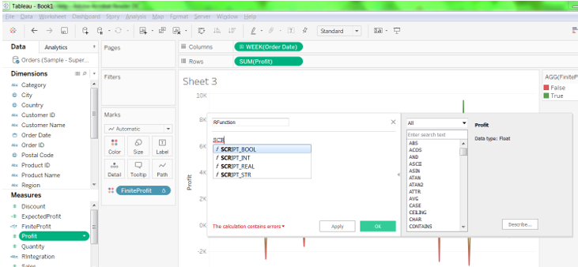](https://lh4.googleusercontent.com/ZTArYBzA3URB-vXtWCCCDaH9LPkVtZFwrJCoI54JuA-crEbCVKY72ci8uOwisT1DHaWxSIHvT8wCrP0yT4UwPPqM1nFaCMbLg4p5bhQ0Jv8A27OT1B4cYoskE1kvQgPDkZ6TUjLEBP03msv7HA)  
**8. Run an R script on Tableau8a → SCRIPT_BOOL**Returns a Boolean result from the specified expression. The expression is passed directly to a running external service instance. In R expressions, use .arg*n*(with a leading period) to reference parameters (.arg1, .arg2, etc.).**SCRIPT_BOOL(" .arg1 > 0 ", SUM([Profit]))**

* In this R example, .arg1 is equal to SUM([Profit])
* All the Fields being passed to R must be aggregated like Sum(PROFIT), MIN(Profit), Max (Profit), ATTR( Category) etc..

[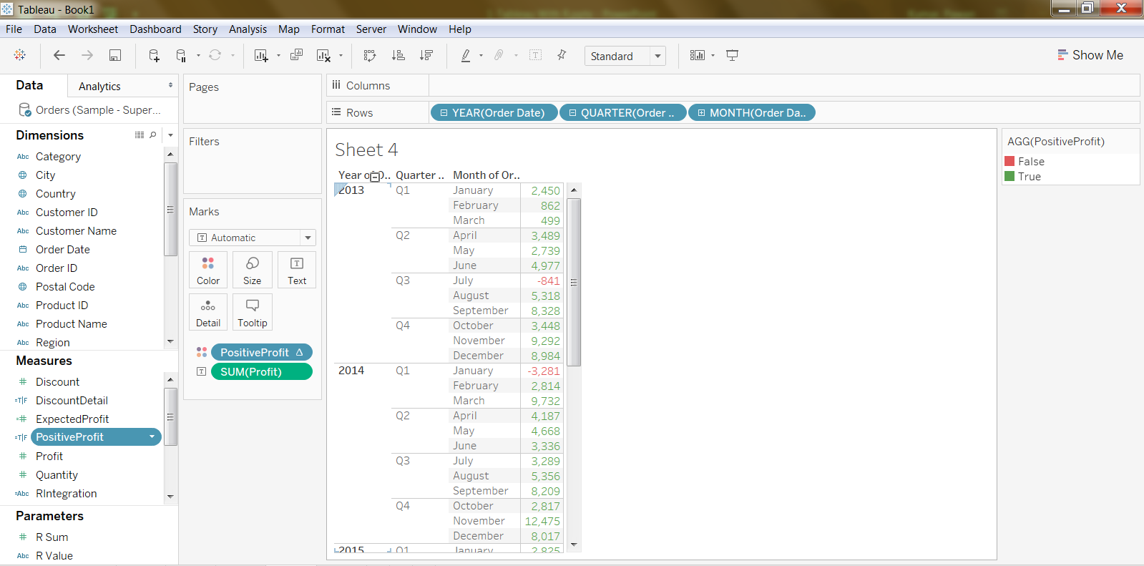](https://lh6.googleusercontent.com/hcFF1GGqU_wfzC8e5FFQHlUmS8VkDJmE2wmJnVG8slzCa3hsKbrV3DBXTC-g60FbvsGBKHFvJ48dSrmqT4sZBmMePMKBXekAnTX7KkXSd-aRlCjJDY2N6kOWZIxG_SfRU53ZXujx5y507OgskQ)  
**8b → SCRIPT_INT**SCRIPT_INT(" .arg1 / 2 ", SUM([Profit]))  
Returns an integer result from the specified expression. In this R example, .arg1 is equal to SUM([Profit])[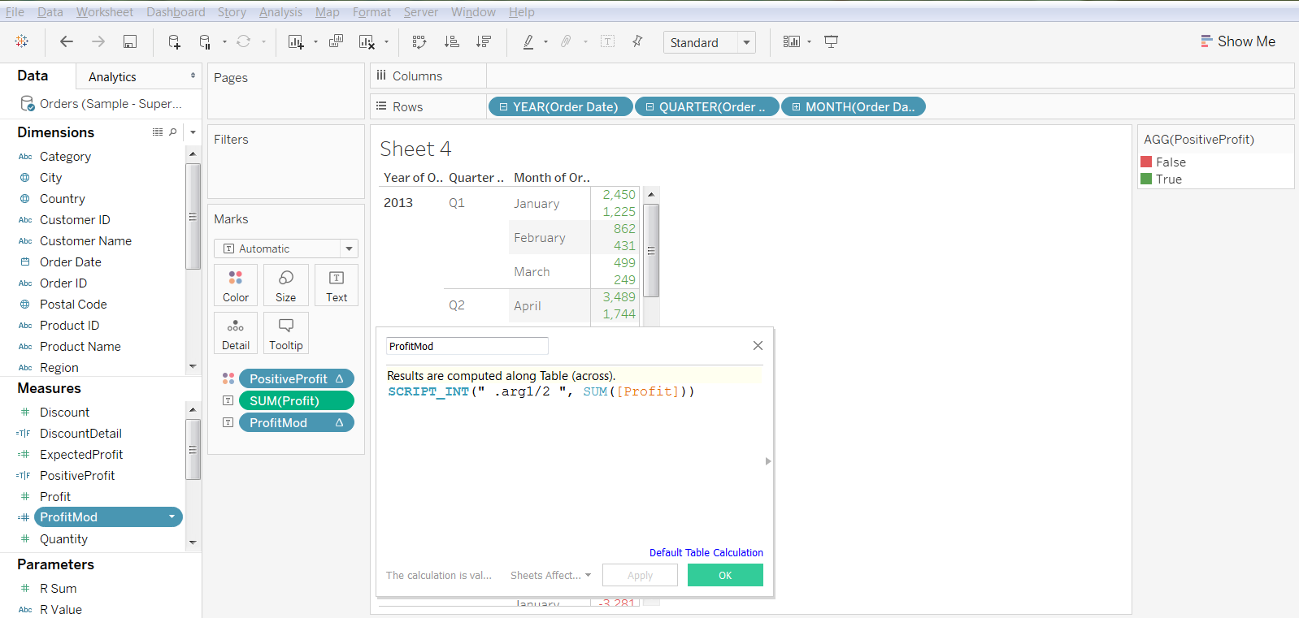](https://lh5.googleusercontent.com/qpwy3fFDmwOaQT0VzTqHZjMpMB3WM4uwiPw0B2PQtb7RnBhBLEIqUo22rodSWmcCXaaW6ljFBPrGjim0qgcMqveHPpRAT1GHoXn1wgDwM_88pCU2zFU6G0MQpPuLoIBAIf_Z0SmfoMyr3aQpeQ)  
**8c→ SCRIPT_REAL**SCRIPT_REAL(" log(.arg1) ", SUM([Profit]))  
Returns a real result from the specified expression. In this R example, .arg1 is equal to SUM([Profit])[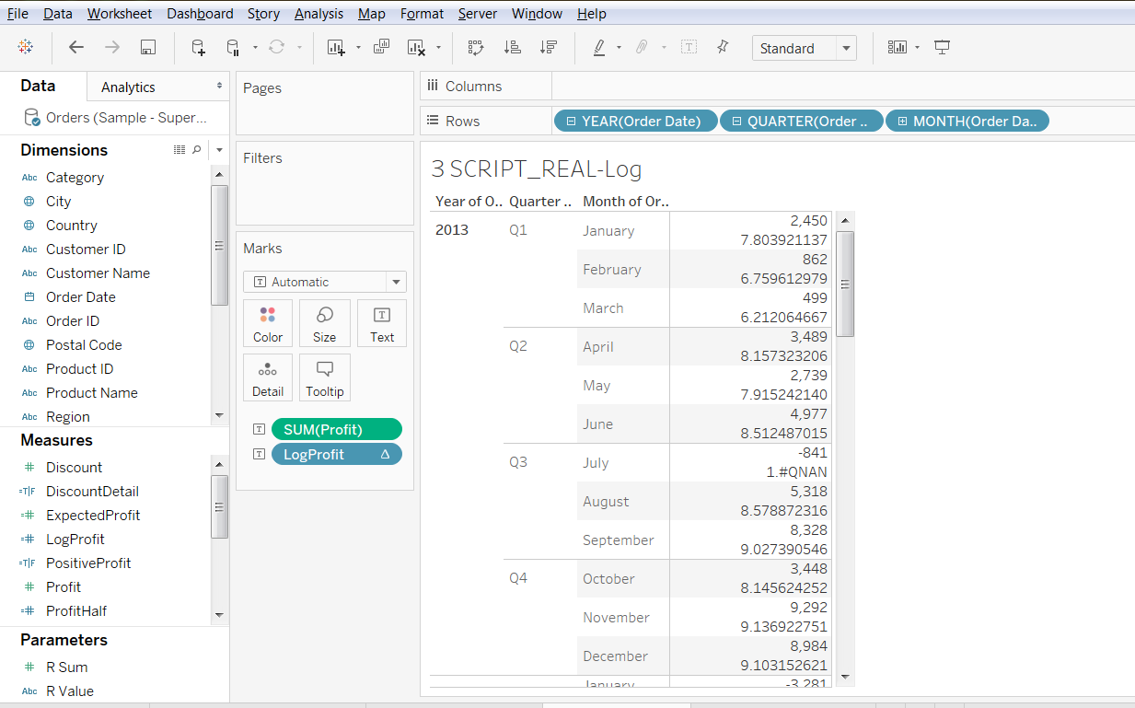](https://lh6.googleusercontent.com/Fd6iJzWsP4soDm9EvyZd8kc2B_W9XnpMJoZAs9Sk3Sb88ng90F3X_MWcmvwnkBh9MWphfjL-k_coRtvdVSMJbL5X0F-_BsrKASaj5gMeaWD-hp59sDPPcoU2h0WVY-4rBuvKXmx42gSD6S6o3A)**8d → SCRIPT_STR**SCRIPT_STR(" paste(.arg1 ,.arg2)",   
attr([Category]),  
attr([Sub-Category])  
)  
Returns a string concatenate result using “R” paste function. In this R example, .arg1 is equal to attr([Category])SCRIPT_STR(" paste(.arg1 ,.arg2)",   
attr([Category]),  
attr([Sub-Category])  
)  
Returns a string concatenate result using “R” paste function. In this R example, .arg1 is equal to attr([Category])  
  
[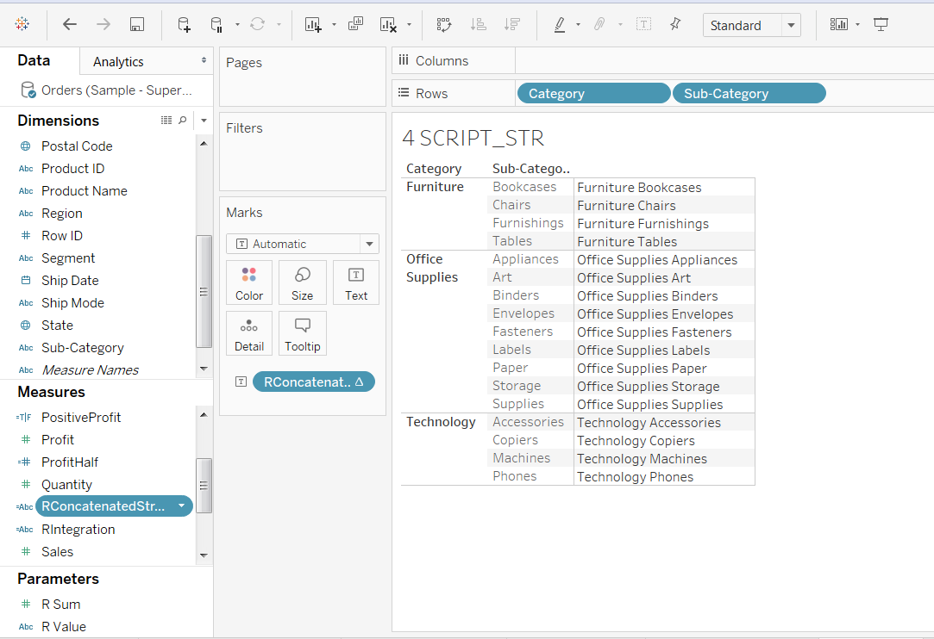](https://lh5.googleusercontent.com/lpd-Wik-WZriQ9DIai5X8paEQ3dWeZ4So92mRqSMPG49oa_ueXQ2g0v4JTgfEOA6Wgdxc-7B00IV-xsgsoFriY9DOkrs9qSf3HMiRxruyd97uoeWdQW3tDdq7FkuGWniGmmfDcStHNTv-8PH4A)  
[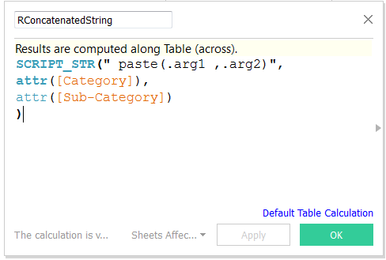](https://lh3.googleusercontent.com/MDPk2Czteg-PHmq63eaA76IeYqAuWijV-WsLcJUE4VZ_RyRLShjrZY6Q4hKDr6mBlCRb5qOI3NCwpslhCjmeOpGWNTqF920g0GZ8dIdLAam5ubaIncu9MOlQD8rDqPahkKfDEcMt24nRjF71dQ)  
  
  
  
  
  
  
  
**9. Share a Workbook That Requires an Rserve Connection**You may need to send a workbook that contains R functionality to other users, who may be using different copies of Tableau Desktop on other computers. Or, users may download a workbook from Tableau Server that contains R functionality. Before users will be able to use the R functionality in workbooks they have received or downloaded to Tableau Desktop, they must Configure Rserve connections on their Computers.  
  
  
  
**10. Publishing Workbooks with an Rserve Connection**

* Publishing a workbook with R functionality to Tableau Server requires Server to have a connection to Rserve.
* If multiple users need to access Rserve simultaneously, Rserve should be installed on Linux.
* Rserve on Linux, unlike Windows, handles each user independently and does not allow users to overwrite other’s objects.
* Before you publish a workbook that relies on an Rserve connection to Tableau Server, you should configure Tableau Server to have its own Rserve connection.
* You do this by configuring settings with tabadmin set.
* The settings are equivalent to the values you set in the Rserve Connection dialog box. They are:
* vizqlserver.rserve.host
* vizqlserver.rserve.port
* vizqlserver.rserve.username
* vizqlserver.rserve.password
* **Note**: The settings vizqlserver.rserve.username and vizqlserver.rserve.password should be omitted if Tableau Desktop connects to RServe without a username and password.

**11. About R integration with Tableau [ As of Tableau 10.1 (April 2017)]**

* You cannot publish workbooks containing R scripts to Tableau Public.
* You cannot view workbooks containing R scripts in Tableau Reader.
* You cannot publish a workbook that contains R scripting to Tableau Online.
* Tableau has been tested with R versions 3.1 and 3.2, and with Rserver version 0.6-8.
* Tableau cannot verify that workbooks that use R will render properly on Tableau Server. There might be scenarios where a required statistical library is available on a user’s machine but not on the Rserve instance that Tableau Server is using.
* For views that cannot be rendered in Tableau Server because of an R script error, you see a warning error when you publish the workbook .
* Because Tableau Server provides an authentication mechanism, it can be more secure to expose Rserve functionality to users through Tableau Server than in Tableau Desktop.